**RESEARCH**

Re - Meaning: “Again” **or** “Anew” **or** “over again”.

Search - Meaning : To examine closely and carefully **or** To test and try **or** To Probe.

Research is:

A careful or systematic study and investigation in some field of knowledge, undertaken to establish facts or principles.

The objective is discovering or revising facts and theories or to discover new knowledge.

Searching for explanation of events, phenomena, relationships and causes

Public research may be more rigorous and objective because it is subject to more scrutiny...Private research (on a company’s product ) may be questioned and biased

**Research is not**

1. Data Collection: An intermediate step to gain reliable knowledge
2. Searching our published results in libraries or the internet
3. An accidental discovery

**Characteristics Of Research**

A good research is:

1. Systematic
2. Logical
3. Empirical
4. Replicable

**Types Of Research**

1. Basic Research: Is a research aimed at expanding the existing base of scientific knowledge regardless of practical application. (a.k.a theoretical research)
2. Applied Research: Is the research that is designed to solve specific practical problems at hand (a.k.a Practical research) e.g market research
3. Qualitative and Quantitative … Explained later
4. Disciplinary research: Is research designed to improve a particular discipline's theories, fundamental relationships and analysis procedures and techniques e.g supply & demand in economics
5. Subject-matter research: is research on a subject of interest for a specific decision maker
6. Problem-solving research: Is designed to solve a specific problem for a specific decision maker
7. Analytic and Descriptive research:
   1. Descriptive research attempts to determine, describe or identify something
   2. Analytic research attempts to establish why something occurs or how it can be

**Qualitative Vs Quantitative Research**

Quantitative Research: It is research Concerned with what can be measured usually using maths like statistics, calculus or discrete maths

Qualitative Research: It is research Concerned with collecting and analyzing data using the perception of the people involved

|  | Qualitative | Quantitative Research |
| --- | --- | --- |
| Types Of Reasoning | Inductive (Infer general from specific) | Deductive (Infer specific from general) |
| Link With Concept | Identifies concepts from situation | Has predetermined concepts concepts and investigates relationships |
| Action | Usually only describes the action in a situation | Tests relationships between concepts on performing an action |
| Outcome | Illuminates the situation by adding examples | Accepts or rejects proposed theory |
| Approach Validity | Truth seen as context bound (socially constructed | Truth seen as objective and universal |

**Research Methods vs Methodology vs Techniques**

Research Method: Is a step by step procedure to achieve a given objective in a given field e.g Recipe book

Research Methods

* Exploratory Research: It structures and identifies new problems and improves basic
* knowledge
* Constructive Research: It develops solutions to a specific problem
* Empirical Research: Is a way of gaining knowledge by means of direct or indirect experience

Research Technique: Is a special approach used to collect and analyse data and draw conclusions in a given field

Research Methodology: Is a general approach to achieve an objective in a given field

A citation or reference in the text is where you refer to an author in the form of direct quote, summary or paraphrasing. Explain the author’s position and comment on it

**REFERENCING**

Why reference?

* You benefit by:
  + Adding authority to your argument
  + Adding credibility to your information
  + Showing off
* Reader benefits by:
  + Understanding the context of your work
  + Being able to track down your work
* Ethical Reasons:
  + Intellectual Integrity
  + Intellectual property issues
  + To distinguish between your idea and someone else’s

**The process Of Research**

1. First a question or problem arises
2. Goals and objectives are defined to deal with the question or problem
3. The research design is developed to achieve the objectives
4. Results are generated by conducting research

The result is interpreted and analyzed

What to reference

* Opinions you may have paraphrased or directly quoted
* Definitions or terms
* Ideas of authors
* Illustrations drawn from a source
* Plans or ideas stimulated by others

Guiding Principle

* Respect the creators ideas and Intellectual property
* Acknowledge the ideas of others
* But don’t reference common knowledge(basic knowledge like Buhari is president of Nigeria)

Referencing convention differs from place to place or subject areas. Softwares use endnote, libraries use homepage e.t.c

Requirement for all referencing conventions

* Acknowledge within the text
* Acknowledge closely as possible to the point
* Include the sources used in a list at the end of your essay
* Include all details about the sources in the list
* The list is usually called reference list, bibliography or list of works consulted

“list of works consulted” and “reference list” are works consulted or referenced

Bibliography is works on topics but not necessarily referenced

**When using quotation**

* Use exact words to support your argument
* Avoid lengthy/frequent quotations
* Quotes are not included in your word count
* For Short quotation, include acknowledgement in the sentence e.g According to Brown (2008), ”... or ...studies” (Brown, 2008).
* For longer quotes
  + Indent 10 spaces from margin
  + Seperate from essay with 2 lines
  + No quotation mark needed
  + Usually introduces with a colon
  + Used for more than 3 lines
  + E.g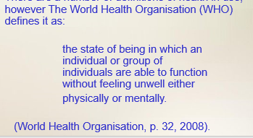
* Use … to omit some words
* To add words to quote, use square brackets. Italics font indicates emphasis e.g “...language [which] contribute… or ...enables a *speaker*, writer...
* [sic] means there is an error in the original
* You can put quotation marks inside quotation mark

**Summarising & Paraphrasing**

* E.g 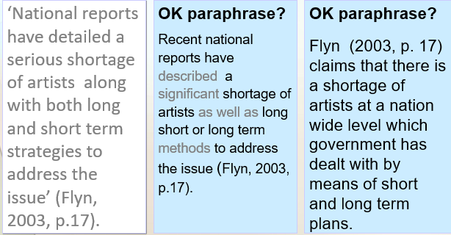
* Start with your own words and only explain main ideas
* Shorten the text and acknowledge the source

**Referencing System In Text**

* Author and date used by harvard and others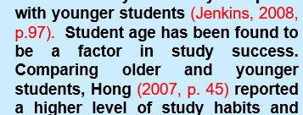
* Numbering which links to footnotes or endnotes used by Oxford and others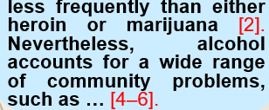
* Numbering which links to the reference list used by Vancouver and others
* To reference newspapers articles, organisations, corporations e.t.c, use the author date method. Organizations and countries can be used as author
* When referencing websites:
  + If author is unknown, treat organisation as author
  + If organisation is unknown,use title of the web page as author
  + If the site is not dated, use ‘n.d.’ for ‘no date’
  + In the reference list, include the date you *accessed* the site, author, date, title of website and url.

**Using Footnotes**

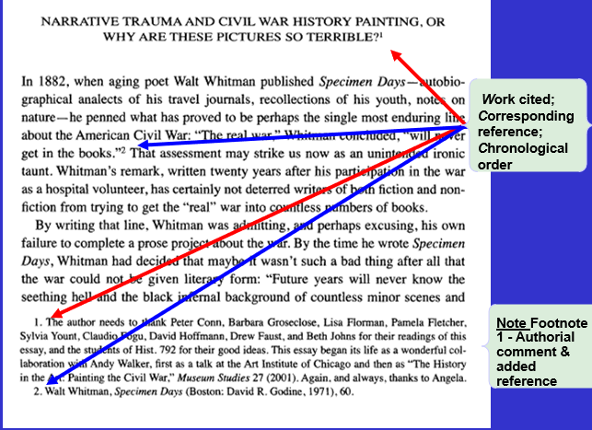

NB: Academic writing needs ref in text and in a list at the end of your work

**Using Reference List**

Necessary Information include:

* Names of author(Last name first)
* Name of journal or book
* Name of article or chapter
* Date of publication
* Journal Volume
* Editor of book
* Publisher
* Place of publication
* Page number(of article)

**Referencing Systems**

1. Alphabetical: Sources appear alphabetically according to family name of first author(this is the most common system)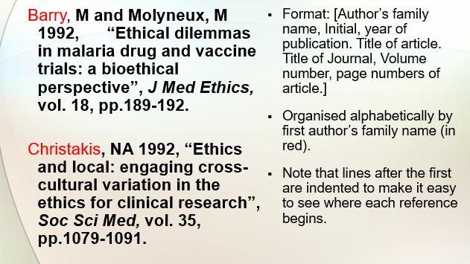
2. Numerical: Sources are listed numerically by the order they are first cited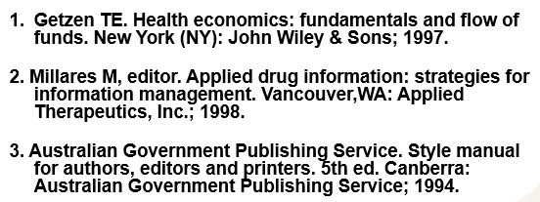

NB:

* Author-date system must include years of publication of the research cited.
* MLA system: year of publication is not required but page numbers generally are.
* If a numerical referencing system is being used, the numbers of the references must be added.

**IPR**

Intellectual property is something produced using human intellect which has commercial Value

Intellectual property rights are the exclusive rights given to persons over the creations of their minds for a certain period of time

**Types are: patents, trademarks, copyrights, and trade secrets**

Patents are for

1. Industrial Properties: Patents, industrial designs, trademarks, trade secrets, plant varieties, integrated circuits, geographical indicators etc
2. Copyright: novels, poem, plays, films, music, drawings, photographs, performing arts, sculpture, software etc

Copyright is the right to reproduce, make copy, adaptations and translations

Term : Usually lifetime of the author until sixty years following the year of death of author

Broadcast Reproduction right: Twenty Five Years

Performers Right: Fifty Years

Authors Rights: Moral Rights-Authorship/Object to Alterations

Resale Share: Right In original Copies

**Other categories O D f Protected Works**

* Derivative work**:** A “derivative work” means a work created by translating, arranging musically, transforming, or dramatizing, cinematizing or otherwise adapting a pre-existing work
* Compilations: Compilations are works (not falling within the term “databases”) which constitute intellectual creations, by reason of the selection or arrangement of their materials .

**TRADEMARKS**

A trade mark is any sign which can distinguish the goods of one trader from those of another. Sign includes words, logos, pictures, or a combination of these. The mark must be: Distinctive, and, not deceptive, or contrary to law or morality, and, not identical or similar to any earlier marks for the same or similar goods.

Trade Secrets:

1. Manufacturing and commercial secrets
2. Consumer profiles
3. Distribution method
4. Manufacturing process
5. Advertising strategies

An example of trade secrets is coca cola invented in 1886 and was never protected by a patent, only by a trademark (for the name Coca-Cola) and by an industrial design (for this very special design of the Coca-Cola bottle...The process of the Coca-Cola drink is only known by two persons in the world not allowed to travel together...Still Pepsi is better😏 ( Femi no Get seNse).

**PATENTS**

A patent is a legal title granting its holder the exclusive right to make use of an invention for a limited area and time by stopping others from, among other things, making, using or selling it without authorization...a patent can be bought, sold, licensed or mortgaged.

Patents are territorial rights, so an Indian patent will only give the owner rights within India and rights to stop others from importing products into India.

E.g - To obtain an Intellectual property for a camera. It’ll be:

* Patent for every individual improved mechanism
* Design for outer shape
* Trademark for brand name or logo denoted as Ⓡ
* Copyright for instruments or manual booklet denoted as ©

Intellectual Property and market

* Differentiates your products and services from others
* Promotes your products and services and creates a loyal clientele
* Diversifies your market strategies to various target groups
* Populaizes you in foreign countries
* Keeps competitors/copiers away

**PLAGIARISM**

From the latin word plagiarius meaning kidnapper, Plagiarism is the presenting the words, ideas, images, sounds, or the creative expression of others as your own

Hi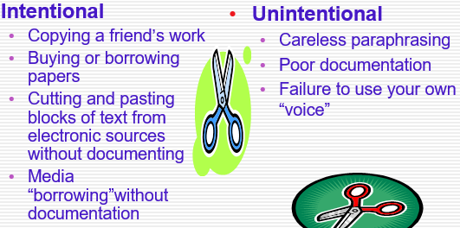

* The most common type of plagiarism is the copying without acknowledgement
* The second most common type of plagiarism is patchwork plagiarism. I.e borrowing phrases and clauses from the original source and weaving them into your own writing without citing the author.
* The third type of plagiarism is paraphrasing plagiarism. I.e when the plagiarizer paraphrases or summarizes another's work without citing the source. Using synonyms but retaining the author's essential thoughts, or style without citing the source is still considered plagiarism.

To Note -

1. The consequences are not worth the risks!
2. It is only right to give credit to authors whose ideas you use
3. Citing makes it possible for your readers to locate your source
4. Cheating is unethical behavior

Consequences To Students Include

1. “0” on the assignment
2. Failing a class?
3. Receiving a lower grade?
4. Parent notification
5. Referral to administrators
6. Suspension or dismissal from school activities--sports and extracurricular

How To Avoid Plagiarism

1. Take notes in your own words
2. If you copy words, put “ ” around them
3. Quote and cite phrases, sentences, and paragraphs taken directly from the original source.
4. When you paraphrase or summarize, give credit to the original author.
5. Keep track or resources you use

* Cite everything except common knowledge
* Wrong! Paraphrasing original ideas without documenting your source, is plagiarism too
* Follow the 3 rules:
  + Quoting: Quotations are exact words of a author word for word
  + Paraphrasing: Paraphrasing is putting someone else’s words or ideas into your own words
  + Summarize

When researching:

* Mark *everything* that is someone else’s words with a big Q (for quote) or with big quotation marks
* Indicate in your notes which ideas are taken from sources (S) and which are your own insights (ME)
* Record all of the relevant documentation information in your notes
* Ensure you note exact page numbers in the reference

**Oral Reports**

According to Brenda Sims, there are four types of oral presentations:

1. Impromptu
2. Extemporaneous (means spoken or done without preparation)
3. Scripted
4. Memorized

Advantages of extemporaneous over scripted:

* Organized
* Prepared
* Conversational
* Can be adjusted to fit audience

Creating An Oral Report

* Organize the report
  + Plan the report
  + Make slides
  + Meet with team structure
* Practice the report
* Create a narrative
* Organize the outline
* Use words or graphics to illustrate
* Stay within the allotted time
* Make the slides with simple background and large fonts (sans serif)
* 1 idea per slide
* Each slide should contain just enough information to guide audience
* Allow 1 or 2 minutes per slide and allow time at the end

**Top Ten Reasons for Evaluating Internet Sources**

1. **There is no quality assurance when it comes to information found on the Internet: Anyone can post anything.**
2. **Some web sites have sponsors who pay for specific content to promote their products or ideas. The information is not impartial but biased.**
3. **Some web sites voice opinions rather than make informed arguments.**
4. **Some web sites are old and the information found there is out of date.**
5. **Some web sites are meant to be entertaining rather than informative.**